Week of Prayer for Christian Unity
This is the Week of Prayer for Christian Unity, and the material which Churches Together in Britain & Ireland has produced in has been prepared by the Monastic Community of Grandchamp in Switzerland. The theme is ‘Abiding in Christ’.
The sisters write;
“Jesus said to the disciples, “abide in my love” (Jn 15:9). He abides in the love of the Father (Jn 15:10) and desires nothing other than to share this love with us: “I have called you friends, because I have made known to you everything that I have heard from my Father” (Jn 15:15b). Grafted into the vine, which is Jesus himself, the Father becomes our vinedresser who prunes us to make us grow. This describes what happens in prayer. The Father is the centre of our lives, who centres our lives. He prunes us and makes us whole, and whole human beings give glory to the Father.
Abiding in Christ is an inner attitude that takes root in us over time. It demands space to grow. It can be overtaken by the struggle for the necessities of life and it is threatened by the distractions, noise, activity and the challenges of life.
We live in a time that is both troubling and magnificent, an often dangerous time where we are challenged by pandemics, wars, violence, poverty, racism and climate change. Yet as Christians seeking reconciliation, justice and peace, we also know the full value of a spiritual life, have an immense responsibility and must realize it, unite and help each other create forces of calmness, refuges of peace, vital centres where the silence of people calls on the creative word of God. It is a question of life and death.”
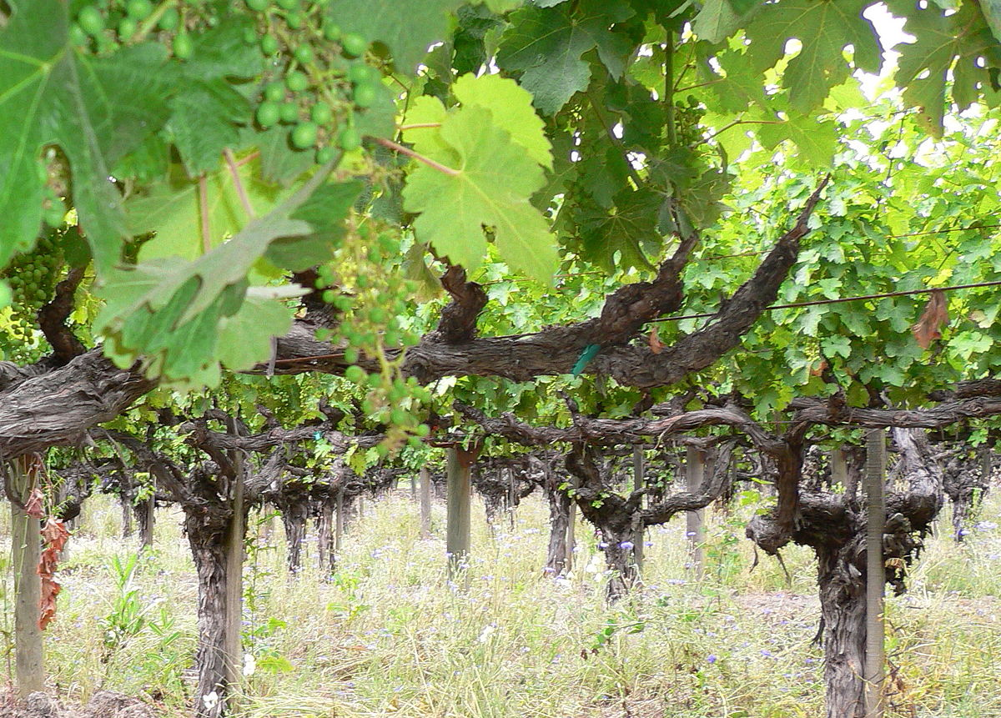
John 15:1-17 ‘I am the true vine, and my Father is the vine-grower. He removes every branch in me that bears no fruit. Every branch that bears fruit he prunes to make it bear more fruit. You have already been cleansed by the word that I have spoken to you. Abide in me as I abide in you. Just as the branch cannot bear fruit by itself unless it abides in the vine, neither can you unless you abide in me. I am the vine, you are the branches. Those who abide in me and I in them bear much fruit, because apart from me you can do nothing. Whoever does not abide in me is thrown away like a branch and withers; such branches are gathered, thrown into the fire, and burned. If you abide in me, and my words abide in you, ask for whatever you wish, and it will be done for you. My Father is glorified by this, that you bear much fruit and become my disciples. As the Father has loved me, so I have loved you; abide in my love. If you keep my commandments, you will abide in my love, just as I have kept my Father’s commandments and abide in his love. I have said these things to you so that my joy may be in you, and that your joy may be complete.

‘This is my commandment, that you love one another as I have loved you. No one has greater love than this, to lay down one’s life for one’s friends. You are my friends if you do what I command you. I do not call you servants any longer, because the servant does not know what the master is doing; but I have called you friends, because I have made known to you everything that I have heard from my Father. You did not choose me but I chose you. And I appointed you to go and bear fruit, fruit that will last, so that the Father will give you whatever you ask him in my name. I am giving you these commands so that you may love one another.

1 Corinthians 1. 10 – 13
Now I appeal to you, brothers and sisters, by the name of our Lord Jesus Christ, that all of you should be in agreement and that there should be no divisions among you, but that you should be united in the same mind and the same purpose. For it has been reported to me by Chloe’s people that there are quarrels among you, my brothers and sisters. What I mean is that each of you says, ‘I belong to Paul’, or ‘I belong to Apollos’, or ‘I belong to Cephas’, or ‘I belong to Christ.’ Has Christ been divided?

Holy Spirit,
vivifying fire and gentle breath, come and abide in us.
Renew in us the passion for unity
so that we may live in awareness of the bond that unites us in you.
May all who have put on Christ at their Baptism
unite and bear witness together to the hope that sustains them. Amen

